ERGM Exploration Activity:

Generating Networks using ERGM

Objective
Exponential Random Graph Models (ERGM) are a family of statistical models that allow us to understand what factors lead ties to form in a network. In analysis, ERGMs are applied to data on an existing network to infer the different network effects (model terms + parameters) that generated the network.

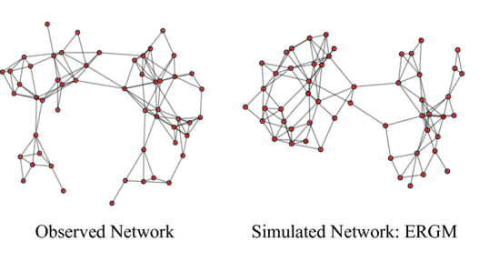
In this exercise, we will demonstrate the reverse: We will come up with model terms + parameters in order to generate a new network that has certain properties. By doing so, we will develop an understanding of how global patterns in networks can be explained by the different local patterns (models terms + parameters) included in ERGMs.

By clicking “go” in our code demo, you will generate a network based on the values of ERGM parameters you have specified. When “go” is clicked, the ties between nodes are updated by performing 100 steps in the Markov Chain Monte Carlo (MCMC) algorithm.

Use the below link to access the interactive web demo:
bit.ly/demoERGM (link is case-sensitive)

Please work with one or two of your neighbors to complete activities 1 and 2.

Instructions
On the web page, you will find an interface for generating networks using ERGMs. In this activity, we will ask you to go through several exercises to generate different types of networks.

ERGMs can be complicated and involve many interdependent parameters. To make the activity easier on you, for each activity we will specify fixed values you should use for some ERGM parameters, and then ask you to experiment with adjusting only one or two parameters in the model.

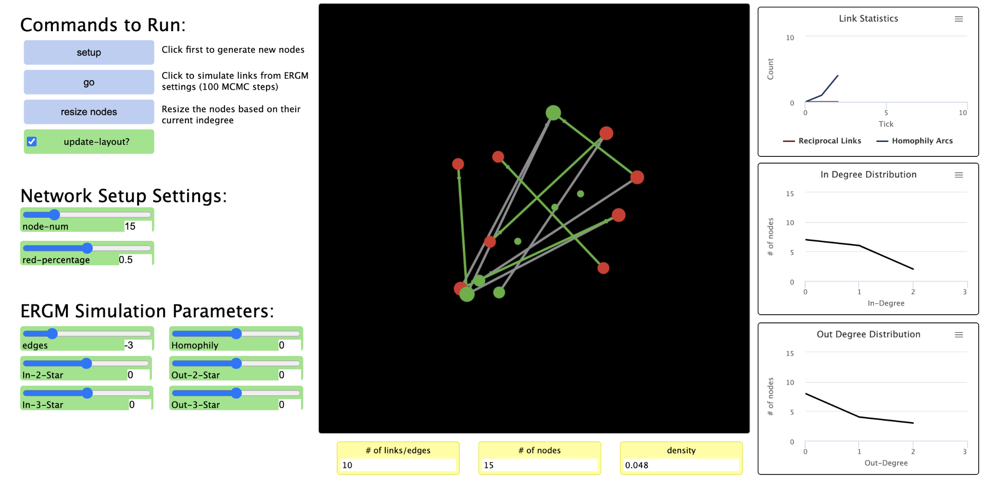

You can generate networks by using the following controls within the webpage:
- Setup:
Run this command first to generate a new network.
- Go:
Each time you click “go” the network will go through 100 steps in the MCMC algorithm to update ties, and then the network plot will update.
When you click “go”, newly generated edges will be shown in green. Pre-existing edges will appear grey.
- Resize Nodes:
- Clicking this button will update the sizes of nodes based on their current degree.
- Network Setup Settings:
These settings affect the composition of new networks everytime you click “setup”
  - Node-num: The number of nodes in newly generated networks
  - Red percentage: The proportion of red nodes in newly generated networks. The remaining nodes will all be green. This matters for network homophily effects.
Activity 1: Homophily
(e.g. within-department vs. cross-department collaboration)

For the first activity we will look at homophily (“birds of a feather”) effects on networks. While homophily can apply to many attributes (gender, age, race, personality, tenure at an organization, etc.), for the sake of this exercise we will look at homophily simply on the basis of node color - red or green.

We can pretend that red nodes represent employees in the sales department of a software company, and green nodes represent employees in the development department in a software company. Homophily effects then capture trends towards within-department (as opposed to cross-department) collaboration.

Fixed parameters:
Please keep the following values fixed for the parameters below:
Node-num: 15
Edges -3.0
All other parameters: 0.0

Experimental parameters:
Please experiment with changing the values (+ or -) for the parameters below:
Red-percentage: 0.50 (need to re-run “setup” each time you click on this
Homophily: Try 0.0. Then try various positive and negative values.

Start with 50% red nodes and a homophily value of 0.0. Click “setup”. After running several hundred MCMC iterations (click “go” a few times), see what the network looks like.

Try this procedure again with a positive “homophily” coefficient.
How does the network change?
Try this procedure again with a negative “homophily” coefficient.
How does the network change?

Activity 2: Indegree Preferential Attachment
For the second activity, we will look at preferential attachment effects - e.g. a popularity effect, similar to “rich get richer” but with network ties.

Fixed parameters:
Please keep the following values fixed for the parameters below:
Node-num: 15
Red-percentage 0.0
Edges -3.0
Other parameters: 0.0

Experiment 1 parameters:
Please experiment with changing the values (+ or -) for the parameters below:
First, click “setup” to restart with a new network.
In-2-Star: Try slight negative values, e.g. -0.3
In-3-Star: Try positive values, keeping In-3-star > abs(In-2-star), e.g. 1.2
Click “resize nodes” to scale the size of nodes based off of their in-degree.

Look at the “Indegree distribution” plot. What does the network look like under these settings? Does it exhibit preferential attachment in-degree? Why?

Experiment 2 parameters:
Please experiment with changing the values (+ or -) for the parameters below:
First, click “setup” to restart with a new network.
In-2-Star: Try slight positive values, e.g. 0.3
In-3-Star: Try negative values, keeping abs(In-3-star) > In-2-star, e.g. -1.2
Click “resize nodes” to scale the size of nodes based off of their in-degree.

Look at the “Indegree distribution” plot. What does the network look like under these settings? Does it exhibit preferential attachment in-degree? Why?

Reflection:
Now, think about a new hypothetical parameter - geometrically weighted indegree - that we will work with in Lab 2. What does this parameters measure? How would you interpret positive, zero, or negative values for this parameter that were obtained from fitting an ERGM?

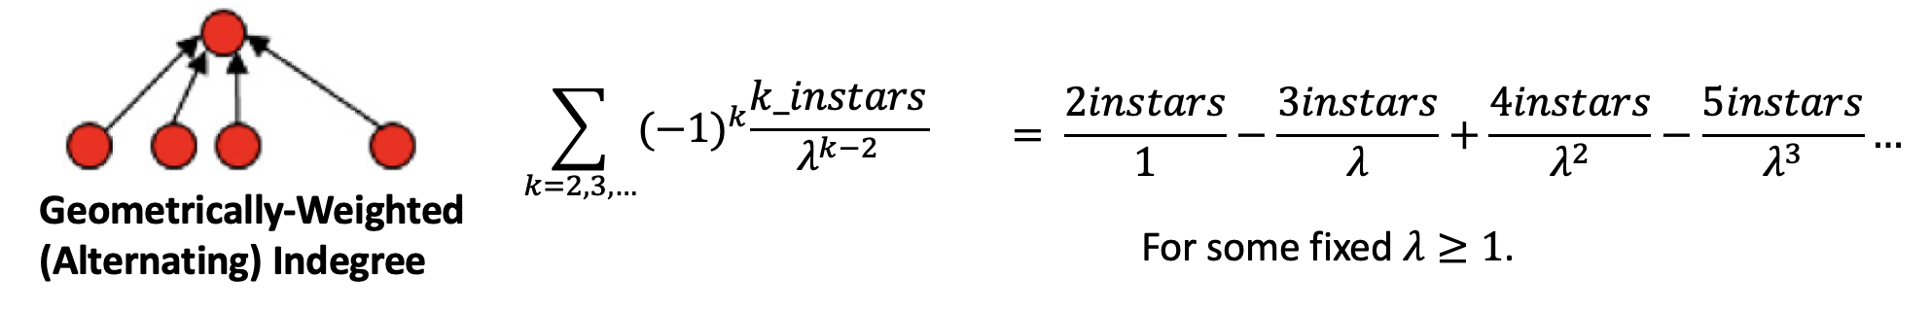

Concluding Take-Aways
While the actual algorithms for fitting ERGM are more complex (MCMC-MLE), essentially it is similar to what you did in this exercise:

- The algorithm is “tweaking” parameters in the model, then simulating networks according to these parameters (using MCMC, Markov Chain Monte Carlo simulation).
- It then looks at the simulated networks and repeats the process and then repeats the process until the simulated networks resemble the real-world network you are predicting (this is MLE, Maximum Likelihood Estimation).

Hopefully, this exercise has given you a non-technical introduction into what the process of estimating ERGM looks like. And you may have noticed how all the parameter values in the ERGM models are interdependent on one another need to be estimated together.

